LAB PROGRAM 7:

create database book_dealer;

use book_dealer;

create table author (

author_id INT,

author_name VARCHAR(20),

author_city VARCHAR(20),

author_country VARCHAR(20),

PRIMARY KEY(author_id));

desc author;

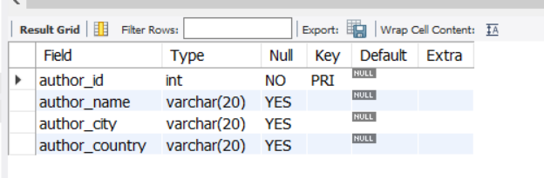

create table publisher (

publisher_id INT,

publisher_name VARCHAR(20),

publisher_city VARCHAR(20),

publisher_country VARCHAR(20),

PRIMARY KEY(publisher_id));

desc publisher;

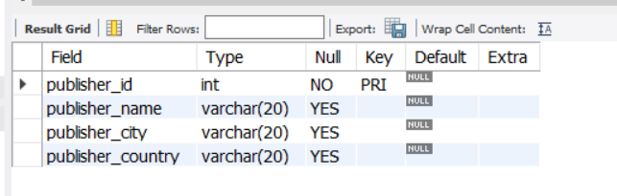

create table category (

category_id INT,

description VARCHAR(30),

PRIMARY KEY(category_id));

desc category;

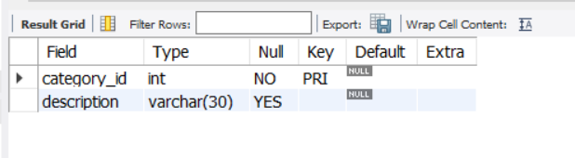

CREATE TABLE catalog(

book_id INT,

book_title VARCHAR(30),

author_id INT,

publisher_id INT,

category_id INT,

year INT,

price INT,

PRIMARY KEY(book_id),

FOREIGN KEY(author_id) REFERENCES author(author_id),

FOREIGN KEY(publisher_id) REFERENCES publisher(publisher_id),

FOREIGN KEY(category_id) REFERENCES category(category_id) );

desc catalog;

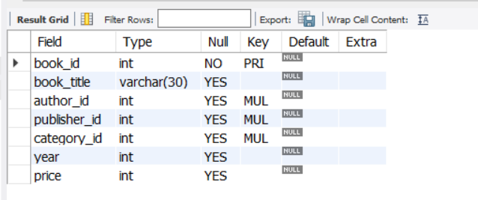

CREATE TABLE orderdetails(

order_id INT,

book_id INT,

quantity INT,

PRIMARY KEY(order_id),

FOREIGN KEY(book_id) REFERENCES catalog(book_id));

desc orderdetails;

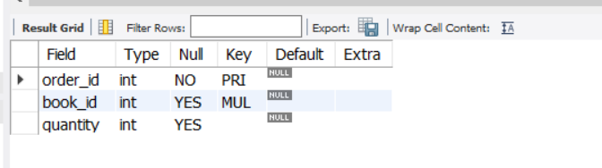

INSERT INTO author (author_id,author_name,author_city,author_country) VALUES

(1001,'JK Rowling','London','England'),

(1002,'Chetan Bhagat','Mumbai','India'),

(1003,'John McCarthy','Chicago','USA'),

(1004,'Dan Brown','California','USA') ;

select * from author;

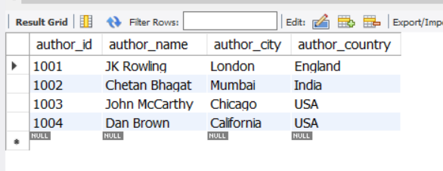

INSERT INTO publisher (publisher_id,publisher_name,publisher_city,publisher_country) VALUES

(101,'Bloomsbury','London','England'),

(102,'Scholastic','Washington','USA'),

(103,'Pearson','London','England'),

(104,'Rupa','Delhi','India');

select * from publisher;

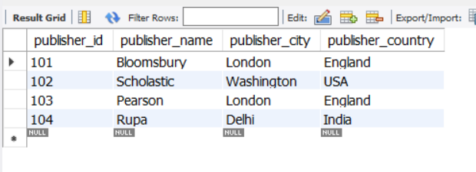

INSERT INTO category (category_id,description) VALUES

(3001,'Fiction'),

(3002,'Non-Fiction'),

(3003,'thriller'),

(3004,'action'),

(3005,'fiction') ;

select * from category;

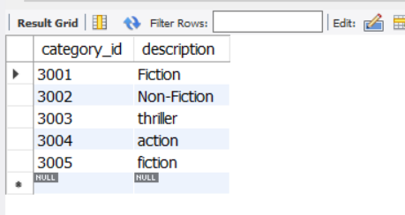

INSERT INTO catalog (book_id,book_title,author_id,publisher_id,category_id,year,price) VALUES

(4001,'HP and Goblet Of Fire',1001,101,3001,2002,600),

(4002,'HP and Order Of Phoenix',1001,102,3001,2005,650),

(4003,'Two States',1002,104,3001,2009,65),

(4004,'3 Mistakes of my life',1002,104,3001,2007,55),

(4005,'Da Vinci Code',1004,103,3001,2004,450),

(4006,'Angels and Demons',1004,103,3001,2003,350),

(4007,'Artificial Intelligence',1003,102,3002,1970,500);

select * from catalog;

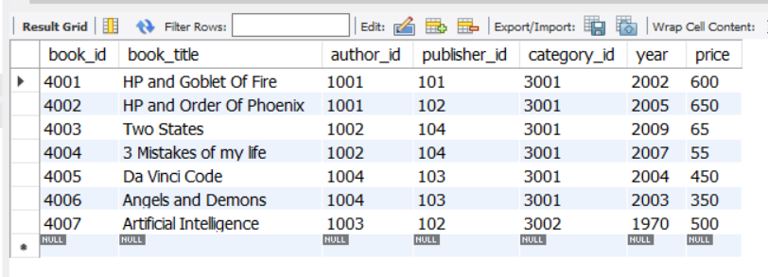

INSERT INTO orderdetails (order_id,book_id,quantity) VALUES

(5001,4001,5),

(5002,4002,7),

(5003,4003,15),

(5004,4004,11),

(5005,4005,9),

(5006,4006,8),

(5007,4007,2),

(5008,4004,3) ;

select * from orderdetails;

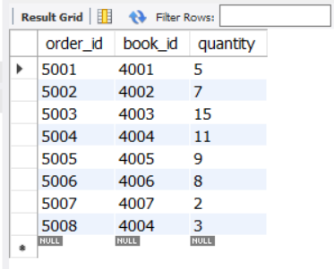

select a.author_id,a.author_city,a.author_name,a.author_city

from author a join catalog c on a.author_id=c.author_id where

year>2000 and c.author_id in(select c.author_id from catalog having

count(c.author_id)>2 and price>500 );

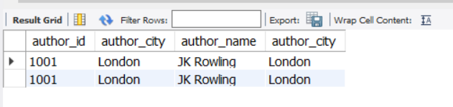

select a.author_id from author a join catalog c on

a.author_id=c.author_id join orderdetails o on c.book_id=o.book_id

having max(o.quantity);

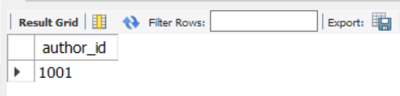

update catalog set price=(0.1*price)+price where publisher_id=2001;

select * from catalog;

commit;

